Name___________________
Ch. 1 Chemistry Foundations- Mastery Questions
Elements or Compounds
Classify each of the following particulate level illustrations as a representation of either an element or a compound.
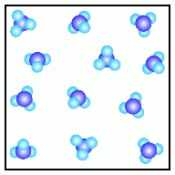 | 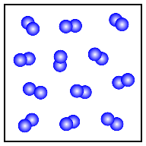 | 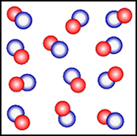

Classify each of the following particulate level illustrations as a representation of either an element or a compound.
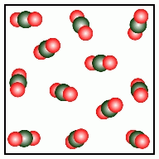 | 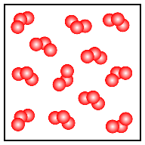 | 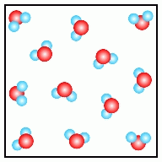

Elements and compounds: Macroscopic
Classify each of the following pure substances as either an element or a compound:
P₄ C₁₂H₂₂O₁₁ Rn
sodium chloride tin polyethylene

Significant Figures in Calculations
When 74.82 is added to 89.7, the result should be reported with how many digits after the decimal point? _______
When 88.034 is subtracted from 98.5, the result should be reported with how many digits after the decimal point? __________
When 74.82 is multiplied by 89.7, the answer should be reported to how many significant digits? __________
When 98.5 is divided by 88.034, the answer should be reported to how many significant digits? __________
When 23.8 and 49.36 are multiplied, how many significant digits should the answer be reported to? __________
What is the result of this calculation (when reported to the correct number of significant figures)? 23.8 × 49.36 = ____________
How many digits after the decimal point should the sum of 23.8 and 49.36 be reported to? ___________
What is the result of this calculation (when reported to the correct number of decimal places)? 2.57 + 2.5 = ____________

Unit conversions: Metric use dimensional analysis or King Henry died….
A dime is found to have a mass of 2.19 grams. What the mass of this dime is in kilograms.

A calculator is found to have a volume of 157 milliliters. What the volume of the calculator is in liters.

Liquid solid gas
At room temperature and pressure, classify each of the following macroscopic samples as solid, liquid or gas:
air oil gold coins
The following illustrations represent different states of the substance water, H₂O, at the particulate level. Classify each as solid, liquid, or gas:
 | 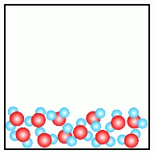 | 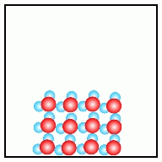

Mixtures and pure substances
Classify each of the following particulate level illustrations as a representation of either a pure substance or a mixture.
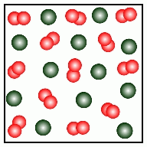 |  | 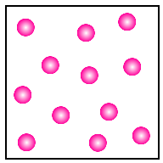

Classify each of the following particulate level illustrations as a representation of either a pure substance, a homogeneous mixture, or a heterogeneous mixture.
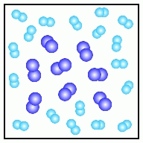 | 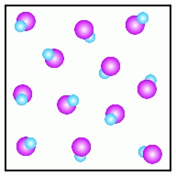 | 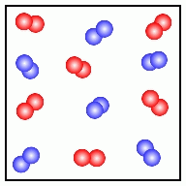
Chemical and Physical Change
Is the change represented by the following illustration best categorized as a chemical change or a physical change?
In the illustration, H is color-coded as light blue and I is color-coded as purple.
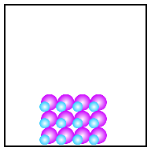

Is the change represented by the following illustration best categorized as a chemical change or a physical change?
In the illustration, N is color-coded as purple and O is color-coded as red.
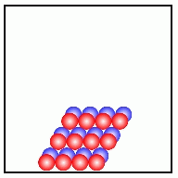

Classify each of the following changes as chemical or physical:
rusting of iron whipping cream ripening of bananas
Classify each of the following properties as chemical or physical:
Basicity stability coarseness

Name___________________
Ch. 2 Atom, Molecules, Ions- Mastery Questions
Ions: Protons and Electrons
An ion from a given element has 13 protons and 10 electrons. What is the charge and symbol on the ion?
An ion from a given element has 53 protons and 54 electrons. What is the charge and symbol on the ion?
Monatomic Ions: Name and Formula
The element fluorine:
Forms a cation/anion (circle one). The symbol and charge ____________for this ion.
The name for this ion is_____________________________ The number of electrons in this ion is ________
The element magnesium:
Forms a cation/anion (circle one). The symbol and charge ____________for this ion.
The name for this ion is_____________________________ The number of electrons in this ion is ________

Monatomic Ions: Write formation
Write an equation that shows the formation of a barium ion from a neutral barium atom.

Write an equation that shows the formation of a iron(III) ion from a neutral iron atom.

Binary Ionic compounds: Name and Formula
What is the name of the compound with the formula CaI₂ ? _______________________________________
What is the name of the compound with the formula MgBr₂ ? _____________________________________
What is the name of the compound with the formula K₂O ? _______________________________________
What is the formula for potassium iodide ? ___________________________________________________
What is the formula for aluminum chloride ? _________________________________________________
What is the formula for magnesium bromide ? ________________________________________________

Binary Ionic compounds with multiple oxidation states
What is the name of the compound with the formula MnO ? ___________________________________
What is the name of the compound with the formula PbI₂ ? ____________________________________
What is the name of the compound with the formula ZnBr₂ ?______________________________
What is the name of the compound with the formula Cr₂S₃ ? __________________________________
What is the name of the compound with the formula FeCl₃ ? __________________________________
What is the name of the compound with the formula MnF₂ ? __________________________________

Ionic Compounds: Formula from ions
Provide the formula from the combination of the following ions.
Cu⁺ and O²⁻ __________________ Pb²⁺ and F⁻ ____________________ Zn²⁺ and Br⁻ ________________________
K⁺ and CH₃COO⁻ __________________ Na⁺ and NO₃⁻ _____________________ Mg²⁺ and NO₂⁻ ______________________
Ionic Compounds: Ions from formulas
The compound MgCl₂ is an ionic compound. What are the ions of which it is composed? _________________________________
The compound NiS is an ionic compound. What are the ions of which it is composed? ___________________________________
Interpreting Formulas
Provide the number of each element in this compound sodium sulfate.

Provide the number of each element in this compound ammonium phosphate.

Ionic compounds- ate
Provide the formula for the following?
magnesium chromate________________ potassium phosphate ________________ aluminum acetate___________________
Provide the name for the following.
KNO₃ _________________________ Al₂(SO₄)₃ ________________________ Mg(CH₃COO)₂ ________________________
Ionic compounds: -ites, per and hypo
Provide the name for the following.
Ba(NO₂)₂_________________________ MgSO₃__________________________________
Provide the formula for the following.
potassium sulfite _____________________________ magnesium nitrite _______________________________
Ionic Compounds OH-, CN-, HCO₃-, HSO₄-
Provide the name for the following.
Al(CN)₃ ___________________ KHCO₃ ____________________ Al(OH)₃ _________________ KHSO₄ _________________

Ionic Compound NH₄+
Provide the name for the following.
NH₄Cl________________________ (NH₄)₂S _______________________ NH₄Br ___________________________
Provide the formula for the following.
ammonium sulfite _________________ammonium sulfide ___________________ammonium fluoride______________________
Covalent Compounds: Name and Formula
Provide the name for the following.
BBr₃__________________________ CO₂_________________________ S₂F₁₀_____________________________

Provide the formula for the following
nitrogen dioxide _____________________ phosphorus trichloride_________________ Sulfur tetrafluoride________________
Ionic, Covalent Compounds: Mixed
Provide the name for the following. .
SO₂____________________________________ Cu(NO₂)₂ ____________________________________
Al(NO₂)₃ _______________________________ P₄O₁₀ _______________________________________
Provide the formula for the following
cobalt(III) nitrate _________________________ nitrogen monoxide ____________________________
barium sulfite____________________________ Diphosphorous tetrafluoride __________________________
Name___________________
Ch. 3 Stoichiometry- Mastery Questions
Average atomic weight
A certain element consists of two stable isotopes.
The first has a mass of 138 amu and a percent natural abundance of 8.90×10⁻² %.
The second has a mass of 139 amu and a percent natural abundance of 99.9 %.
What is the atomic weight of the element?

The element copper has an atomic weight of 63.5 and consists of two stable isotopes copper-63 and copper-65.
The isotope copper-63 has a mass of 62.9 amu and a percent natural abundance of 69.1 %.
The isotope copper-65 has a percent natural abundance of 30.9 %.
What is the mass of copper-65?

Elements: Atoms/Mol conversion SHOW WORK
How many moles of V are there in a sample of V that contains 2.81×10²⁴ atoms?

How many S atoms are there in 4.08 moles of S?

Elements: Gram/Mole Conversion SHOW WORK
How many moles of Hg are there in 98.0 grams of Hg? How many grams of Li are there in 0.948 moles of Li?

Gram/Atom conversion SHOW WORK

How many Pb atoms are there in a 67.4 gram sample of Pb ?

How many grams of Xe are there in a sample of Xe that contains 1.07×10²⁴ atoms?

Compounds: Calculate Molar mass SHOW WORK
barium bromide . carbon tetrafluoride.

Compounds: Mol/Mass Calculations SHOW WORK
How many grams are in the following?
4.17 moles of copper(II) sulfide 4.94 moles of boron trifluoride

How many moles are in the following?
3.32 grams of copper(II) sulfide 1.70 grams of boron trifluoride

Compounds: Mol/Number conversion SHOW WORK
How many ATOMS of phosphorus are present in 4.57 moles of phosphorus trichloride ?

How many MOLES of chlorine are present in 3.37×10²² molecules of phosphorus trichloride ?

How many MOLECULES of boron trifluoride are present in 1.72 moles of this compound ?

How many MOLES of boron trifluoride are present in 1.19×10²² molecules of this compound ?

Compounds Mass/number calculation SHOW WORK
How many molecules are in the following?
9.02 grams of of phosphorus pentachloride 2.52 grams of boron trichloride

How many grams are in the following?
1.05×10²³ molecules of phosphorus pentachloride 8.27×10²² molecules of boron trichloride

Compound: Mass to Mass SHOW WORK
How many grams of sulfur are in 1.13 grams in SCl₂ ? How many grams of chlorine are in 1.11 grams of SCl₂ ?

How many grams of magnesium are in 2.10 grams Mg(NO₂)₂? How many grams of nitrogen are in 2.13 grams of Mg(NO₂)₂?

Formula to percent Composition SHOW WORK
What is % by mass of chromium(III) in Cr₂O₃ ? What is % by mass of chlorine in C₂H₅Cl ?

Balancing equations SHOW WORK
Provide the balanced equation for the following.

sodium chloride (aq) + silver nitrate (aq) silver chloride (s) + sodium nitrate (aq)

bromine (g) + chlorine (g) bromine monochloride (g)

Equations: Mol/Mol calculation SHOW WORK

According to the following reaction, how many moles of hydrogen gas will be formed upon the complete reaction of 0.840 moles water? water (l) hydrogen (g) + oxygen (g)

According to the following reaction, how many moles of potassium sulfate will be formed upon the complete reaction of 0.226 moles potassium hydrogen sulfate with excess potassium hydroxide?
potassium hydrogen sulfate (aq) + potassium hydroxide (aq) potassium sulfate (aq) + water (l)

Equations: Mass/Mol calculation SHOW WORK

According to the following reaction, how many grams of hydrobromic acid are necessary to form 0.811 moles bromine?
hydrobromic acid (aq) hydrogen (g) + bromine (l)

According to the following reaction, how many moles of calcium sulfate will be formed upon the complete reaction of 32.8 grams of sulfuric acid with excess calcium hydroxide?
sulfuric acid (aq) + calcium hydroxide (s) calcium sulfate (s) + water (l)

Equation Mass/Mass Calculation SHOW WORK
According to the following reaction, how many grams of iodine are required for the complete reaction of 21.6 grams of hydrogen gas? hydrogen (g) + iodine (s) hydrogen iodide (g)

According to the following reaction, how many grams of dinitrogen monoxide will be formed upon the complete reaction of 25.8 grams of ammonium nitrate? ammonium nitrate (aq) dinitrogen monoxide (g) + water (l)

Limiting Reactants: Molecular Level
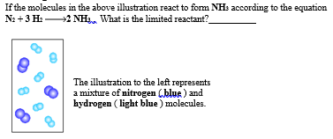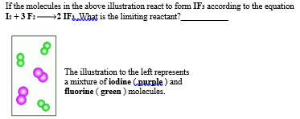

Limiting Reactants comparing Reactants SHOW WORK
For the following reaction, 0.794 grams of hydrogen gas are allowed to react with 15.2 grams of ethylene (C₂H₄) .
hydrogen(g) + ethylene (C₂H₄)(g) ethane (C₂H₆)(g)
What is the theoretical yield of ethane (C₂H₆) that can be formed? Identify the limiting reactant___________________

What mass of the excess reagent remains after the reaction is complete?_______________

For the following reaction, 41.9 grams of aluminum oxide are allowed to react with 108 grams of sulfuric acid .
aluminum oxide(s) + sulfuric acid(aq) aluminum sulfate(aq) + water(l)
What is the theoretical yield of aluminum sulfate that can be formed? Identify the limiting reactant___________________

What mass of the excess reagent remains after the reaction is complete?_______________

Percent Yield
"In our bodies, sugar is broken down with oxygen to produce water and carbon dioxide."
For the following reaction, 4.41 grams of glucose (C₆H₁₂O₆) are mixed with excess oxygen gas. The reaction yields 4.40 grams of carbon dioxide.
glucose (C₆H₁₂O₆) (s) + oxygen (g) carbon dioxide (g) + water (l)

What is the theoretical yield (in grams) of carbon dioxide?
What is the percent yield of carbon dioxide ?

For the following reaction, 5.48 grams of sulfur dioxide are mixed with excess water . The reaction yields 5.99 grams of sulfurous acid (H₂SO₃) .
sulfur dioxide ( g ) + water ( l ) sulfurous acid (H₂SO₃) ( g )

What is the theoretical yield of sulfurous acid (H₂SO₃) ?
What is the percent yield of carbon dioxide ?

